Jenkins email notifications:

Step 1: Now, we need to install the email-notification plugin follow the bellow steps.

1.1Go to Jenkins Dashboard choose the manage_jenkins and double click as shown below screen shot.

Double click on Configure System as shown below screen shot

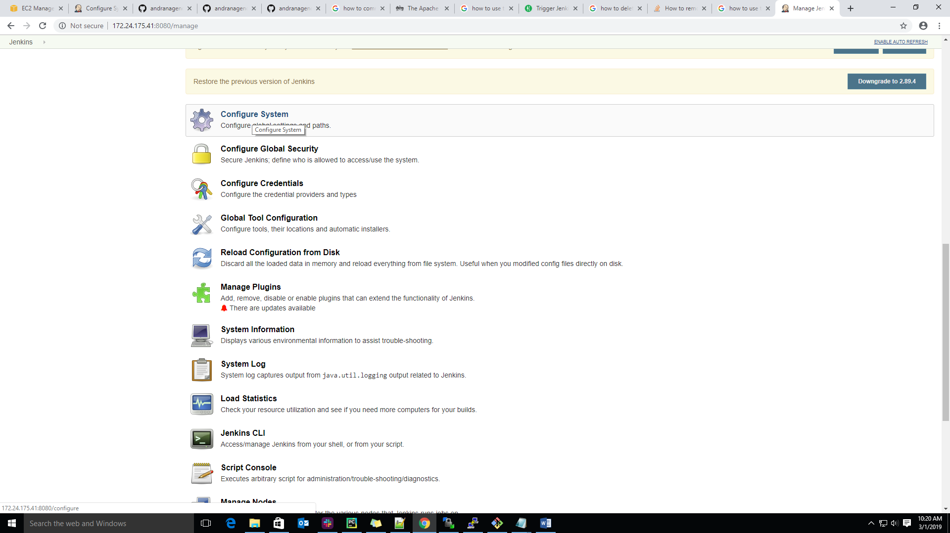

Step2: After, double click on configure system we will get the new pop window then scroll down up to

Email notification option

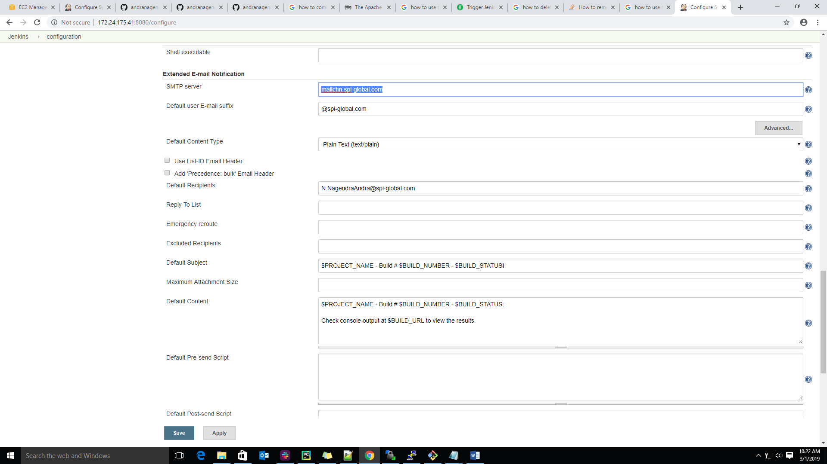

Step 3: An email notification we need to enter the mail server details and mail id suffix as shown below screen shot.

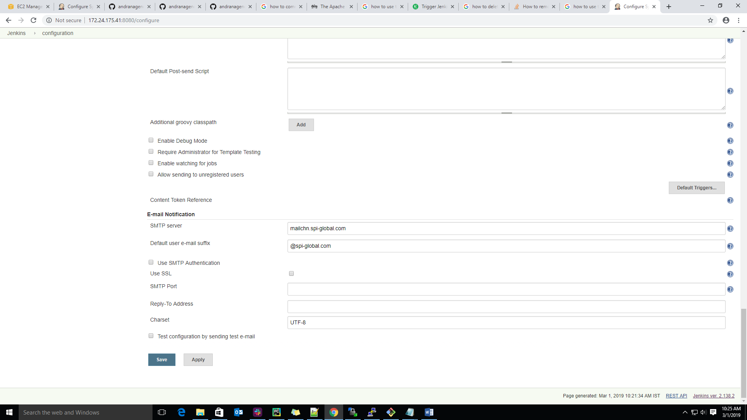

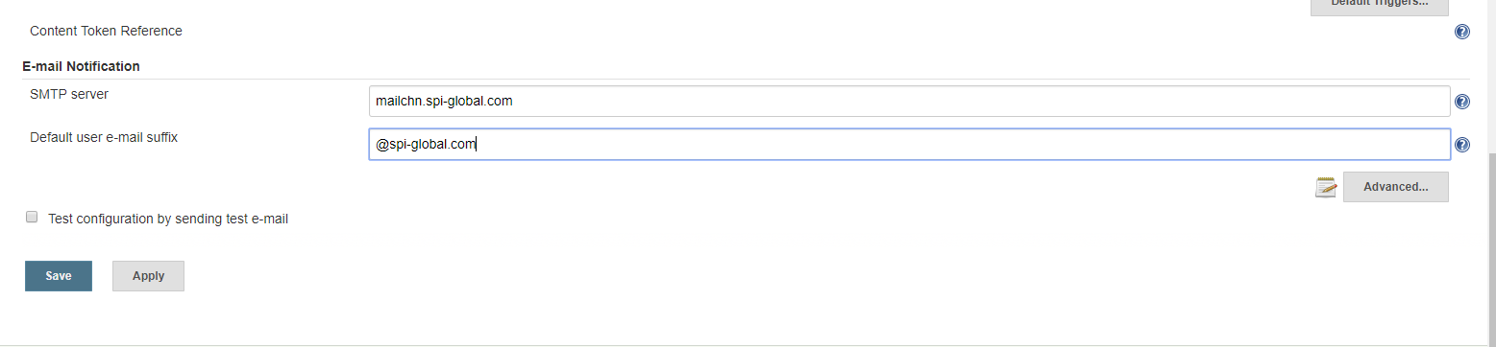

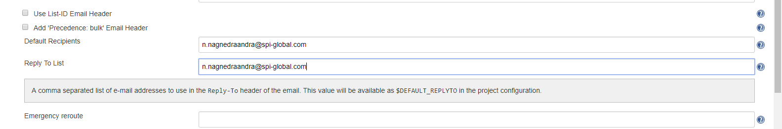

Git hub:



